PULSE AND OXYGEN SATURATION MONITORING SYSTEM USING ARDUINO UNO

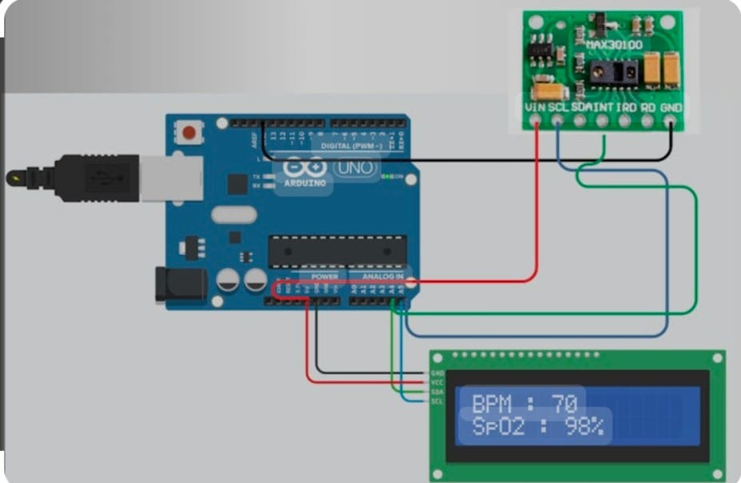

Project Overview:
- The Pulse Monitoring System using the MAX30100 Pulse Oximeter sensor and Arduino Uno is designed to monitor a person's heart rate (BPM) and blood oxygen saturation levels (SpO2) in real-time. The readings are displayed on a 16x2 I2C LCD screen and provide an efficient way to track vital health metrics at home or in clinical settings.

Objective:
- To design and implement a low-cost, real-time pulse monitoring system using Arduino Uno, MAX30100 sensor, and an I2C LCD display to measure and display heart rate and SpO2 levels.

Hardware Components:
- Arduino Uno
- MAX30100 Pulse Oximeter Sensor
- 16x2 LCD with I2C interface
- 9V HW Battery with Connector
- Connecting Wires
- Breadboard (optional)
- USB Cable (for programming)

Software Requirements:
- Arduino IDE
- MAX30100_PulseOximeter Library
- LiquidCrystal_I2C Library

Circuit Connections:
- MAX30100:
- VIN to 3.3V on Arduino
- GND to GND
- SDA to A4
- SCL to A5
- LCD I2C:
- VCC to 5V
- GND to GND
- SDA to A4
- SCL to A5
- Power:
- 9V Battery via HW connector to Arduino barrel jack
- USB connection for programming and power (alternative)

Working Principle:
- The MAX30100 sensor uses infrared and red LEDs to detect pulse and oxygen levels in the blood. The Arduino collects this data via I2C and calculates BPM and SpO2, displaying the result on the LCD. A callback function detects each heartbeat and prints a message on the LCD.

Circuit Diagram:

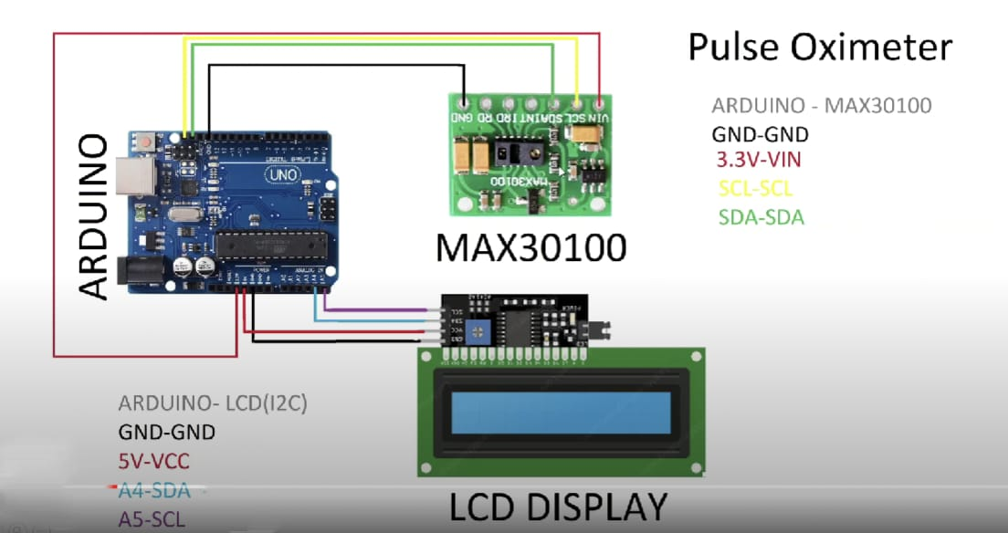

Arduino Code For Pulse and Oxygen Saturation Monitoring System:

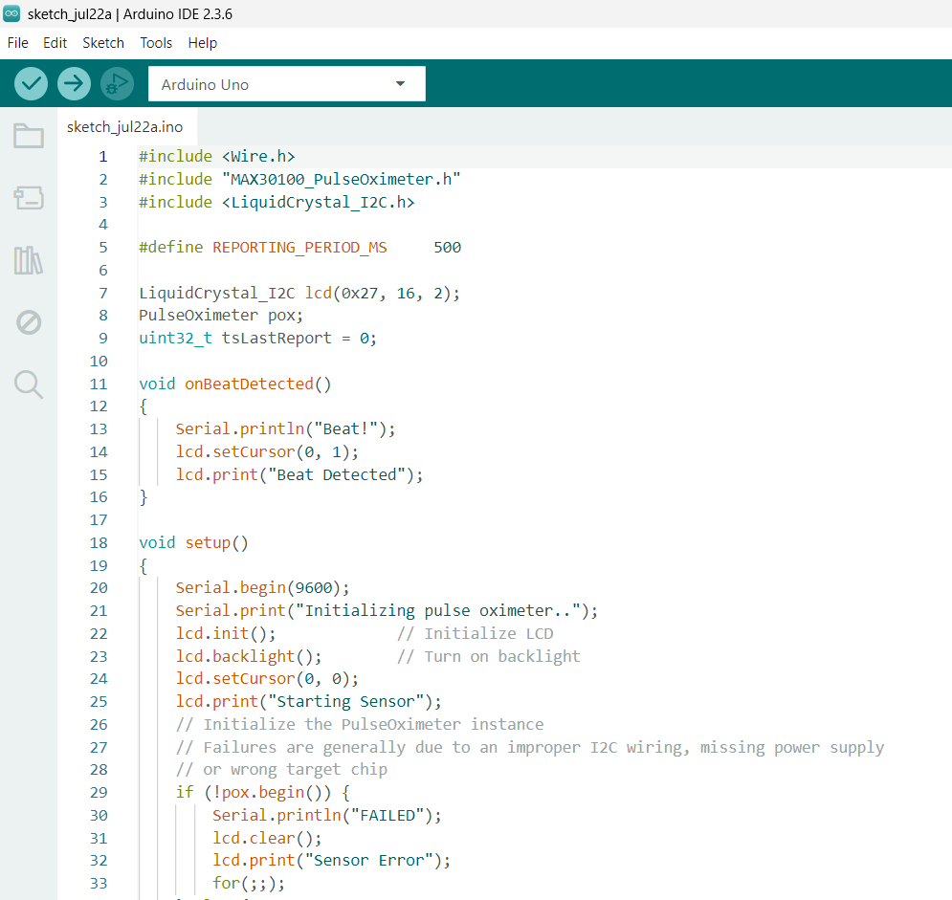
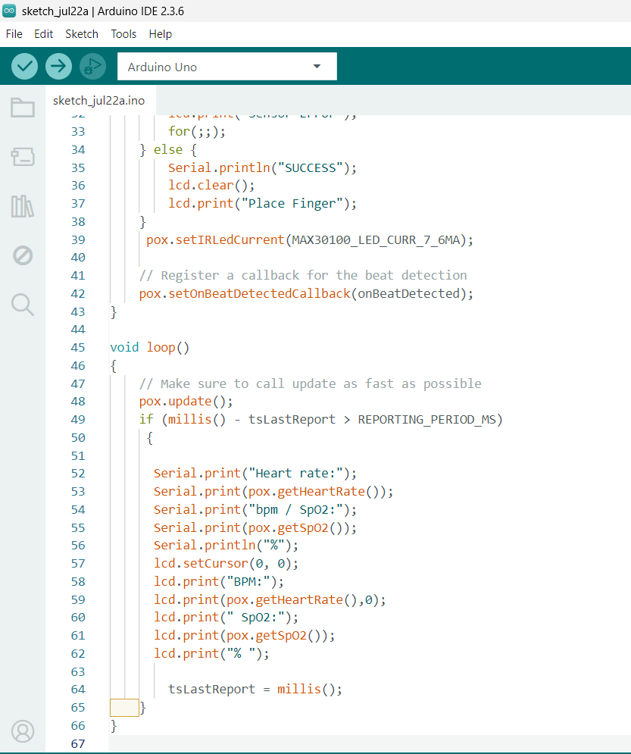

Applications:
- Home health monitoring
- Fitness tracking and remote patient monitoring
- Educational and prototyping purposes
REAL TIME WORKING PROCESS
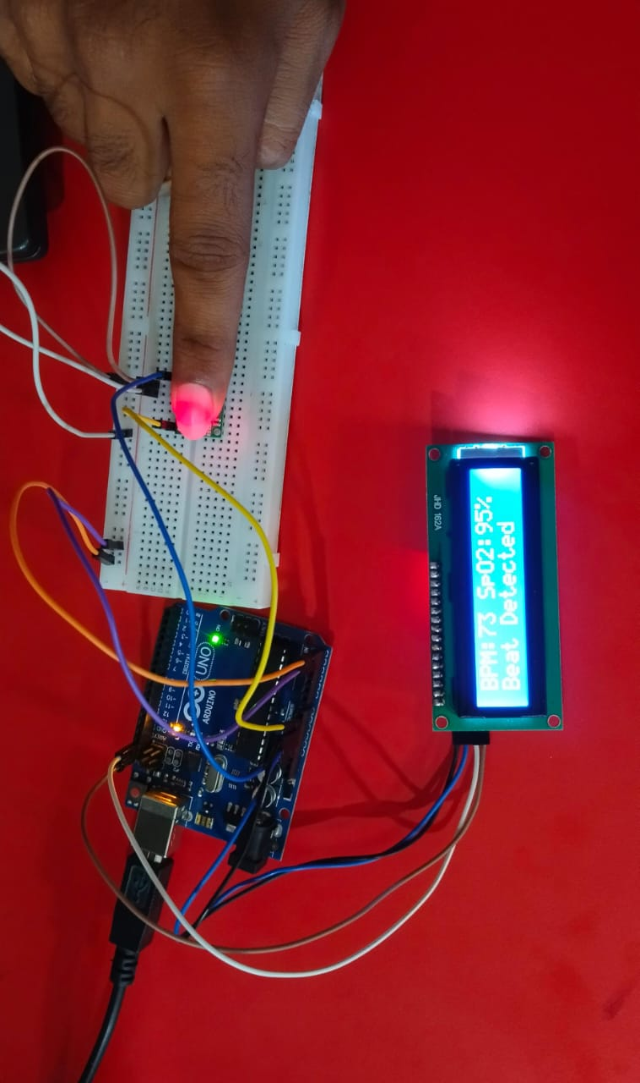

Limitations:
- Sensitive to finger movement
- Not medically certified
- Requires stable 3.3V power for MAX30100
- Accuracy can be affected by ambient light or poor placement

Conclusion:
- This project demonstrates a simple and effective way to monitor vital health parameters using accessible components. With accurate pulse and oxygen level detection, it serves as a valuable tool for health awareness and learning embedded systems.

